Memorable Catalina Cruise

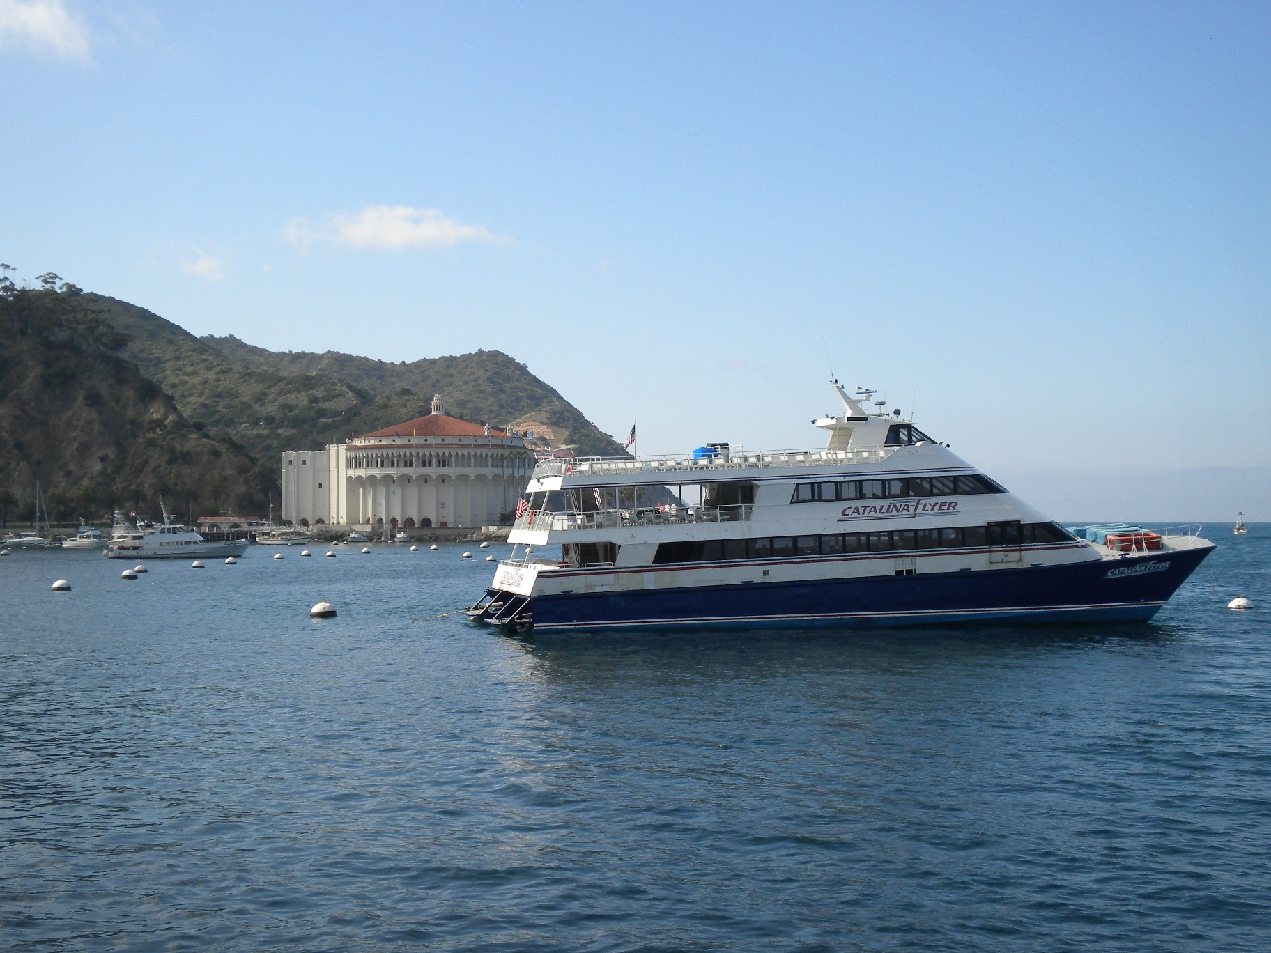
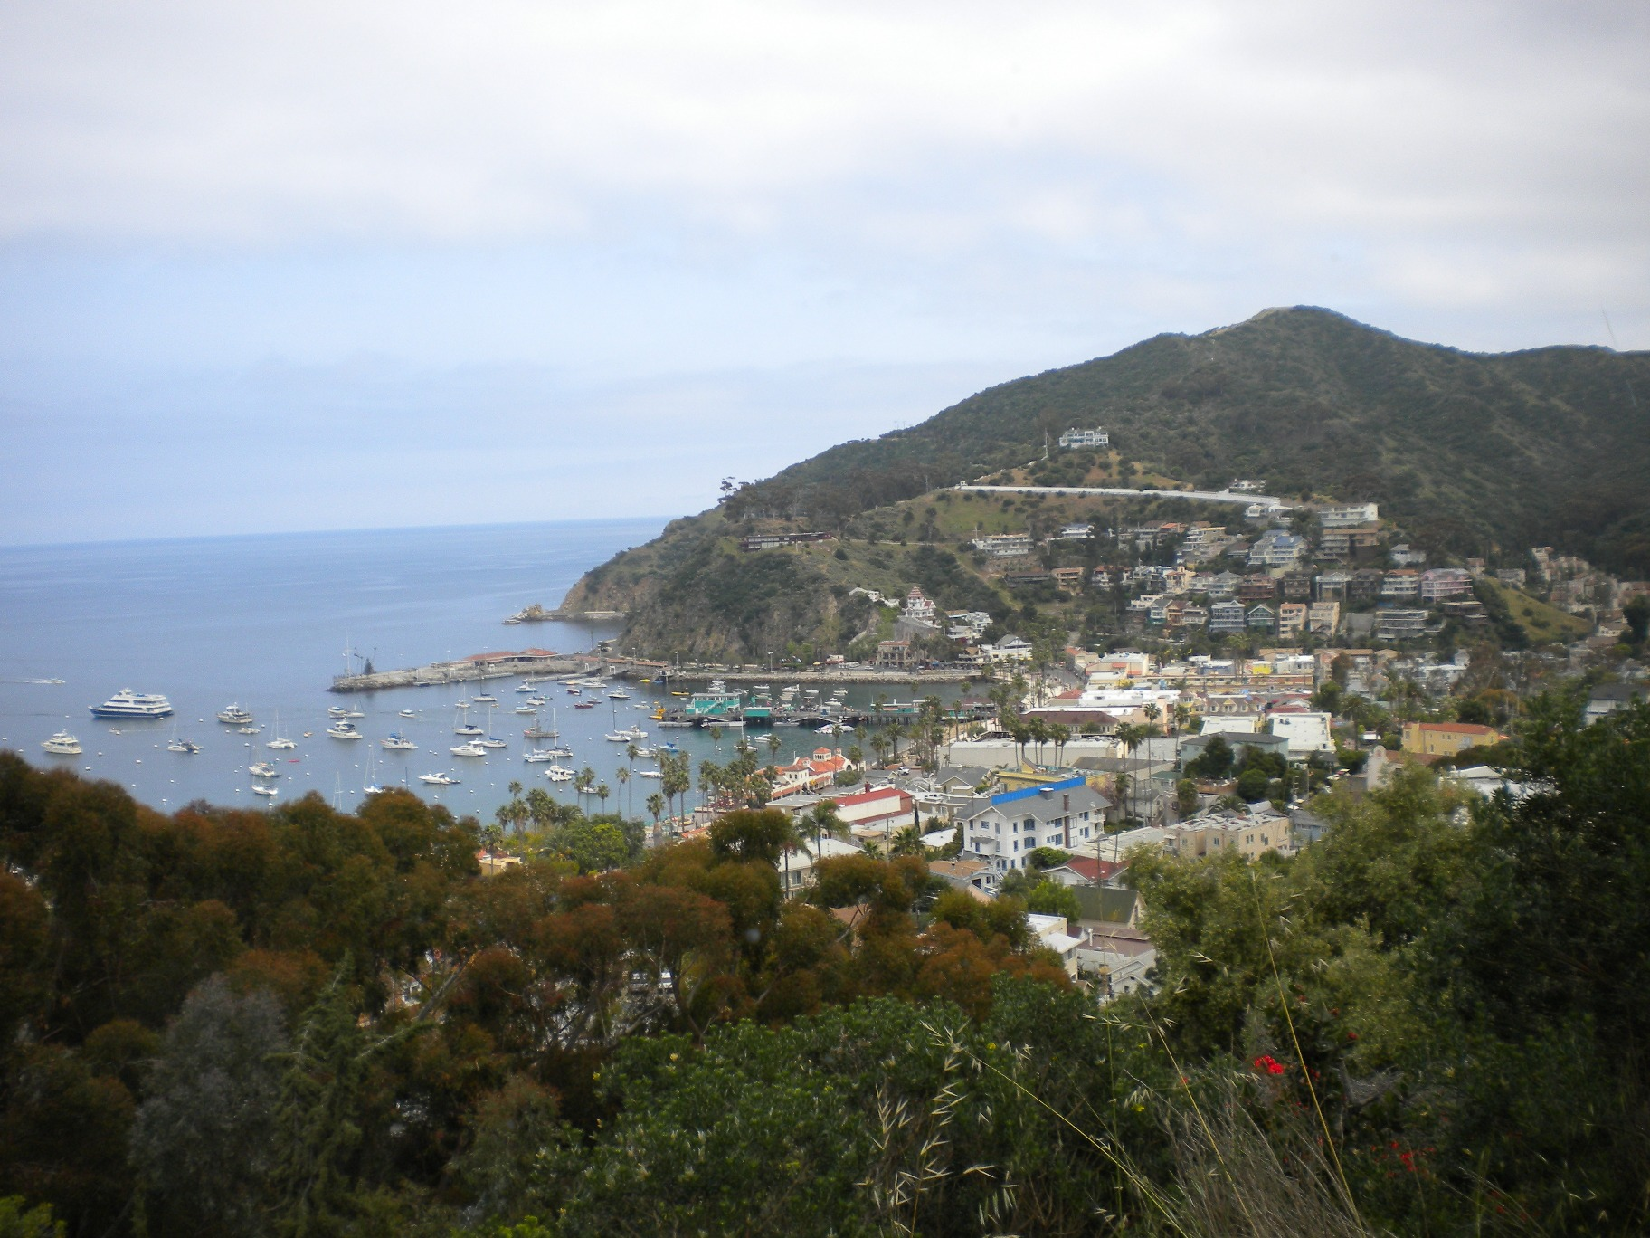
We set sail from Newport Harbor at 9 am on April 19th. The skies were a little gray and the sea a little rough. However, everyone did survive this part of our mini vacation, to enjoy the entire rest of our “Econo Cruise”. 48 Fullerton Elks and guests were able to make it on this short but fun trip
(out of the 50 who signed up). On the left is our boat (not sure if it is big enough to call a ship), in Catalina harbor, from
the docks. On the right is a picture of the harbor with the Wrigley Mansion centered on the hillside behind.

After dispersing from the docks, people all went their own ways. It was kind of cozy and quaint that way. Couples went on Romantic little jaunts, by themselves. PDDGER, Dave and Barbara Redfearn were one such couple.

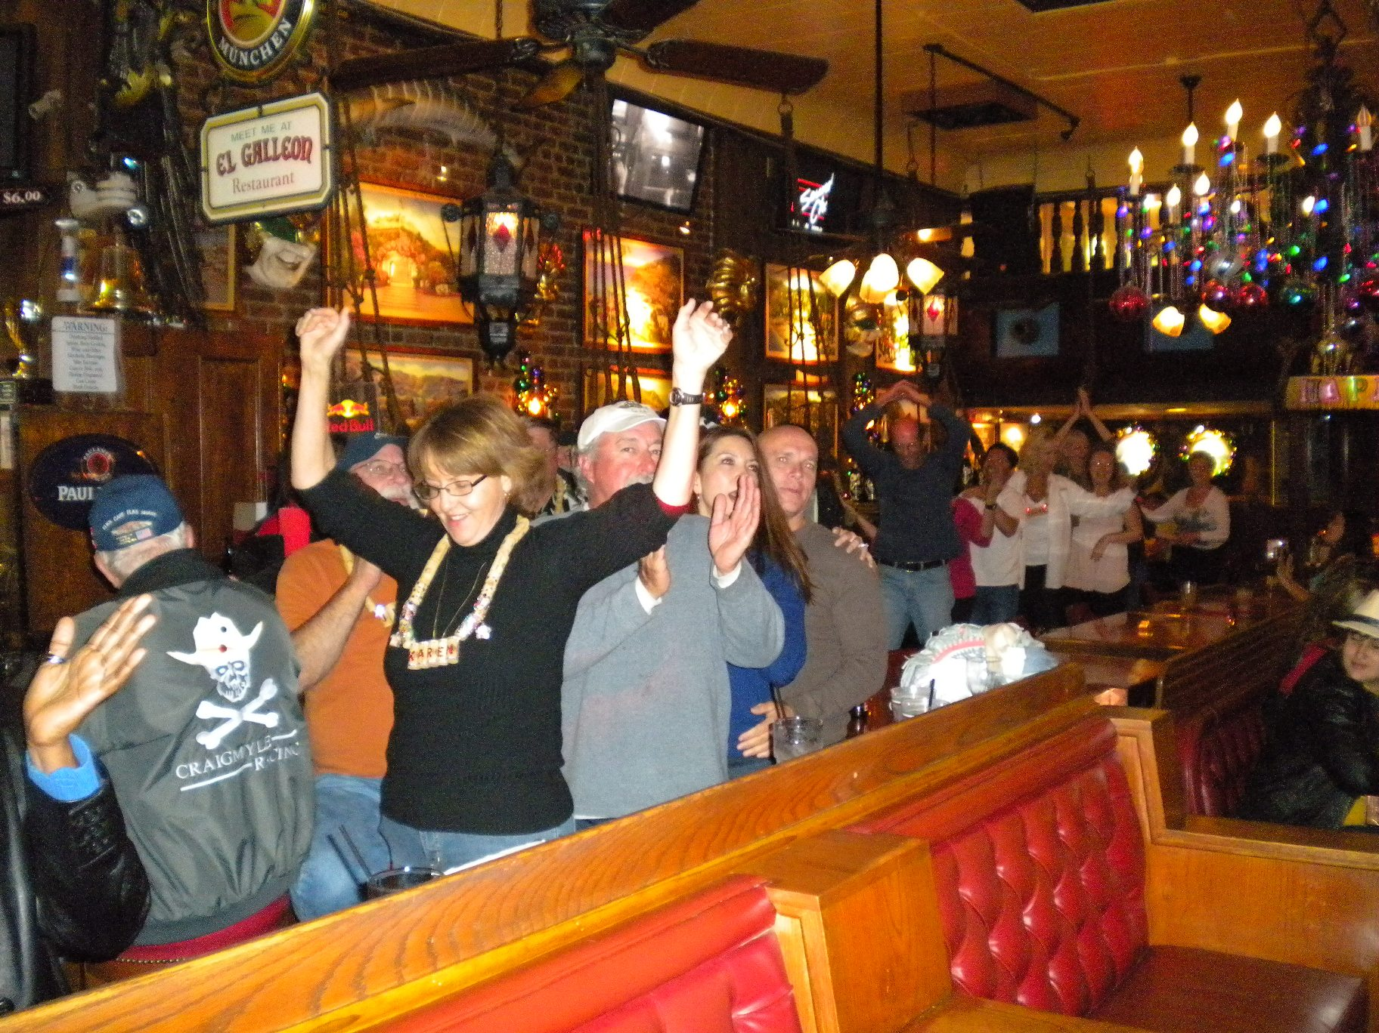
Many of the party animals stuck together, hitting bars, donning ridiculous looking new hats,
shopping and sampling much of the wild and fun side of Avalon. This was all much easier to do after the Carnival Cruise ship pulled out of port. Many of us sat and waved goodbye to them, from a bar patio, while we sipped our frozen concoctions.

Some of our travelers took a guided tour of the town, some toured farther out (going up to the airport and where the Buffalo roam). Others took advantage of water craft sight-seeing and still others toured the old Casino. Did you know that the Casino has never had any gambling? It did offer many dances, to 1300 people at a time.

The local cuisines offered many new delights for our palates and dining was usually enjoyed overlooking the harbor. About 20 of us had dinner at a fabulous steak house on the boardwalk, called Steve’s. Quite a few of us decided we needed to burn off some of that heavy food with some nightlife. 2 doors down was a great little place that offered not only great spirits and a great view of the harbor as well. Our own Karaoke Divas got everyone in the place fired up for the evening. They were even a driving force on the bar-wide Conga Line, led by Karen Dudley (as you can see here). Yes, the Corkers were once again well known, by the time we left this little island paradise.

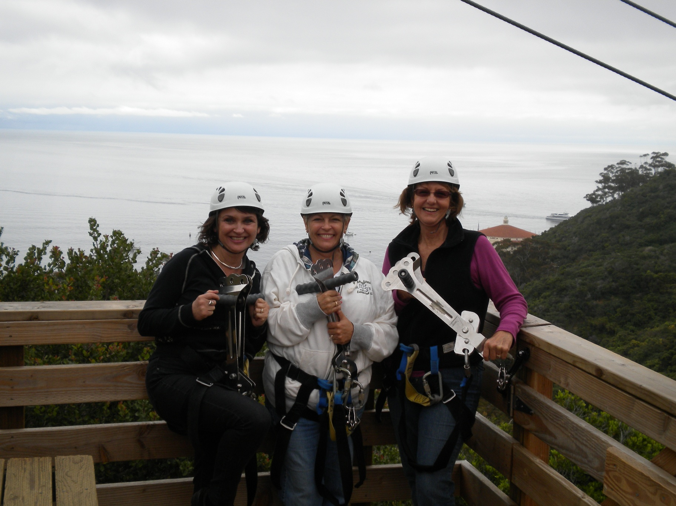
Now, some of our travelers were more adventurous than others. As you can see here at the right, Mary Kay, Valarie & Karen went Zip lining (one of the brand new adventures to experience on Santa Catalina Island). They had a thrilling time speeding through the forests-tops, with views of the harbor below.

Eventually we had to return home and the seas were much calmer. We stopped in to visit our friends at the Newport Harbor Elks lodge, immediately after disembarking. We were greeted there with a fabulous Taco meal, which we enjoyed overlooking their harbor. Most of us were too tired to stick around for their Line dancing afterward, but our support did help them raise $200 for the Purple Pig that evening. Speaking of finances, even though this was a very inexpensive trip, we did raise $360 for the Fullerton Elks.

Hope to see you on our next cruise.

Scott Stephens

