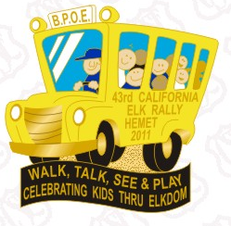
Golden Village Palms
October 6,7 and 8, 2011
California Elks invite you to the 43rd Annual “Elk RV Rally” to benefit our crippled kids. This week-end is open to the public, everyone is welcome to come! Every cent of the funds raised at this event goes directly to “our kids” to provide physical therapy, in-home care, vision screening and much, much more at no cost to the family.

The Line-Up

Thursday Oct. 6 - Preliminary Booth Set-up during the day
6pm - 3 pieces of Pizza & soda $5.00
7pm - Auction off the “Royal Piggies”
7pm - Gold’n West Duo plays under the stars

Friday Oct. 7 - All booths open, all vendors vending all day
1pm - Pig Races
6pm - Mexican Dinner $10
7pm - Dave Ambrose with some “belt buckle rubbin’” songs

Saturday Oct 8 - Booths & Vendors open until 1pm
3pm - Salute to the Military & First Responders by local musicians
Police Dog Demonstration
6pm - BBQ Dinner $10
7pm - Rock out with “Rockin’ Rhonda”

Sunday Oct. 9 - Breakfast 7am - 9am
9:30am - Winning Tickets Drawn for door prizes
Winners of Baskets Announced
Monies Collected and Good - Byes said

There is so much happening this week-end that it won’t fit on the page. The most important thing is to join us, play with us, help us, so we can help them.

A COIN A DAY AND THEY’LL WALK, TALK, SEE AND PLAY

3600 W. Florida Ave. www.elksrally.com
Hemet, CA 92545

