The Fullerton Elks Lodge
Presents
Luck-o-the Irish
St. Patrick’s Day Event
March 14, 2009

5:30pm- Cocktails & light Irish hors d’oeuvres, over Celtic music
(Special Irish beers & drinks)

6:30pm- Traditional Irish meal; Juicy Corned Beef & Cabbage, Potatoes, Carrots & Soda Bread, then a wonderful Apple Crumble dessert (Irish Coffee available for a wee bit more).

8pm- Bon Family Cloggers - River Dance show
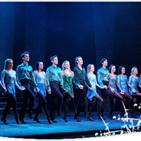

Then Dance the rest of the night away
with your own Leprechaun, to another band.
No Blarney kissing will be allowed. Win a Pot of Gold
contest.

RSVP to the lodge office with your $29ea. check NOW! ($40 after March 1st)
Or call chairman Scott Stephens with questions (714)801-6230.
*Jacket & tie are not required, costumes are ok, but NO jeans or T-shirts will be allowed. Seating reserved by date of RSVP and it is Limited .

