The More the Merrier
This old adage was proven once again at the April 2010
Campout, in the Seal Beach Naval Campground. Wagon Masters
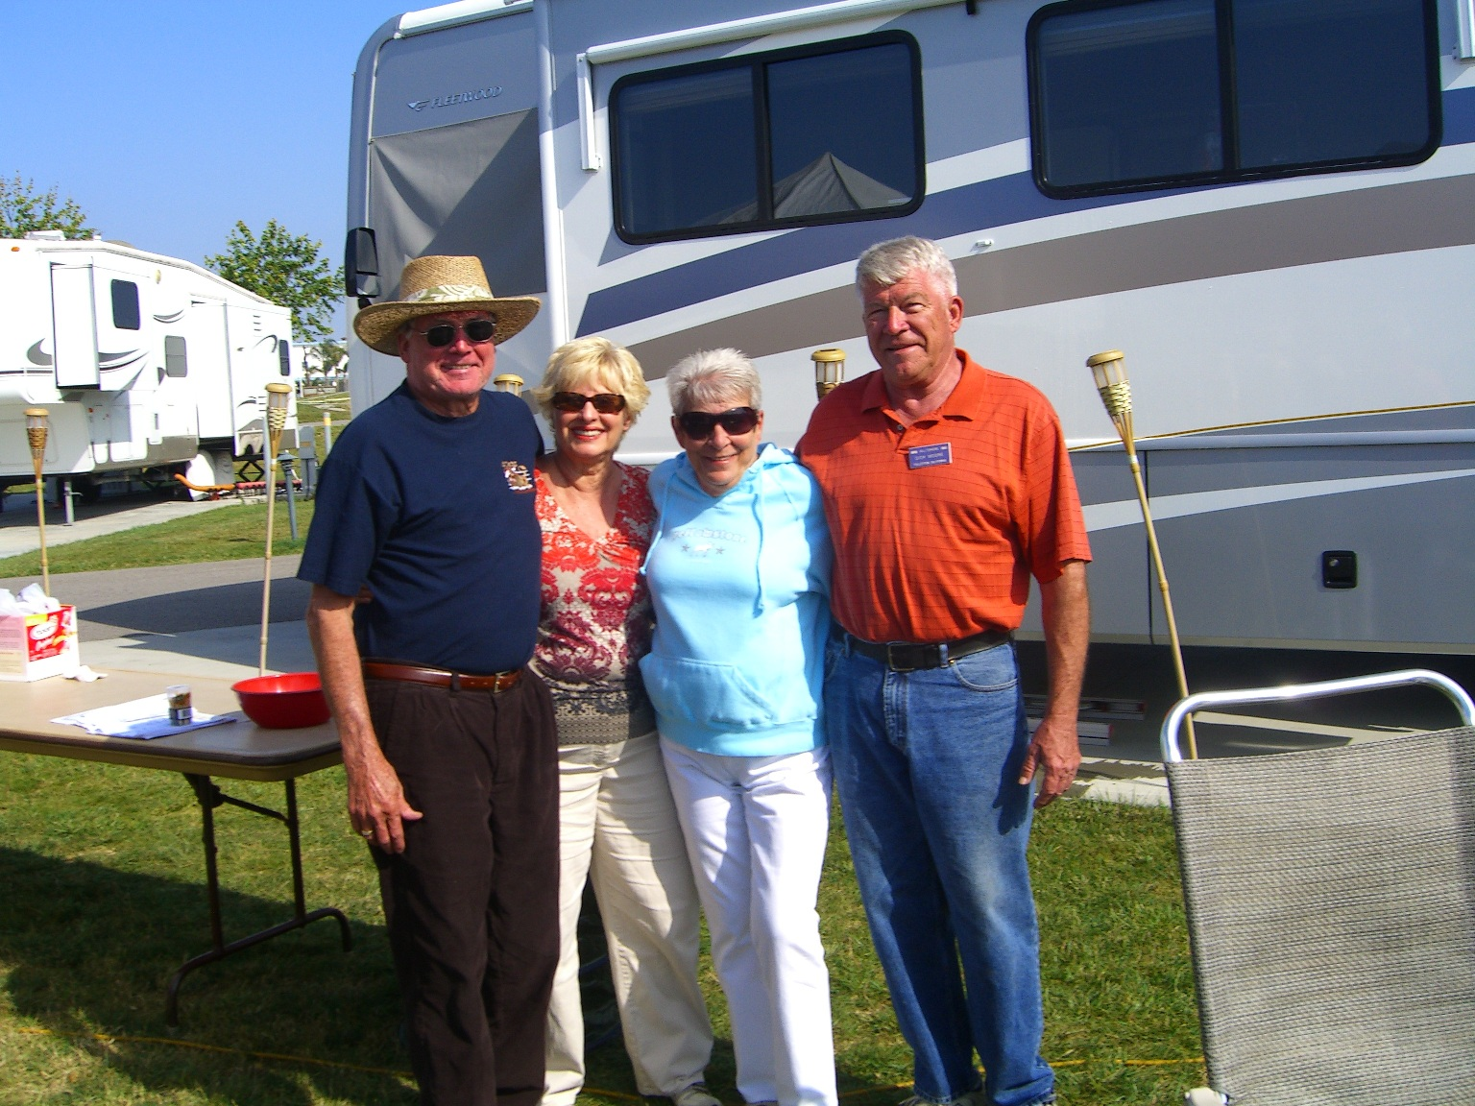
PER, Dick & Mary Moore and Co –Wagon Masters Bill & Pauline
Ling hosted this well attended event. They managed to do a
wonderful job even with Dick & Mary having to leave Saturday
night for the Buena Park Inaugural Ball.

There were a total of 30 rigs at this campout. That’s half
of our entire club. One of the truly great things about it was that
there were plenty of new faces and old, from far and near.
Leaving much to talk about and share, the entire weekend.

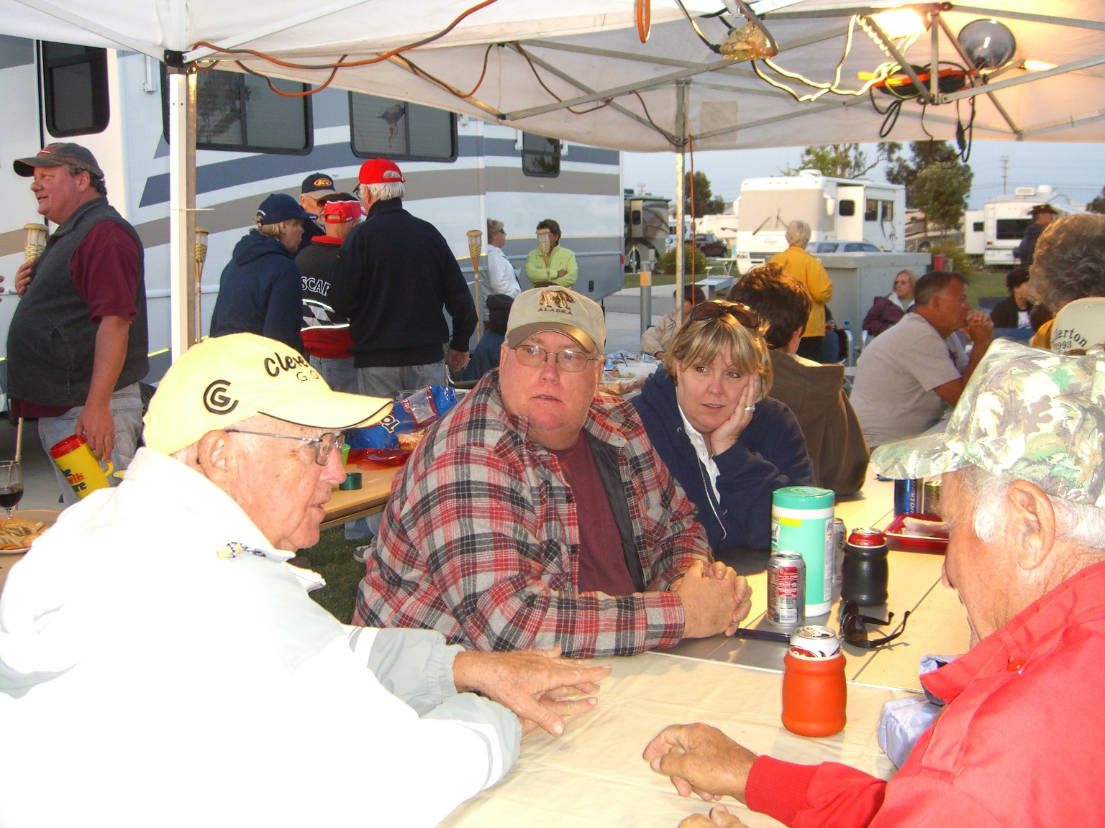
Pictured above are our wonderful wagon masters for the weekend and here on the left are two of our newest members, Mike & Kim (daughter of Dave & Trish Miller).
Then below here you’ll see the winner of Sunday’s 50/50 raffle, Ron VonSoosten, with his $96 windfall.

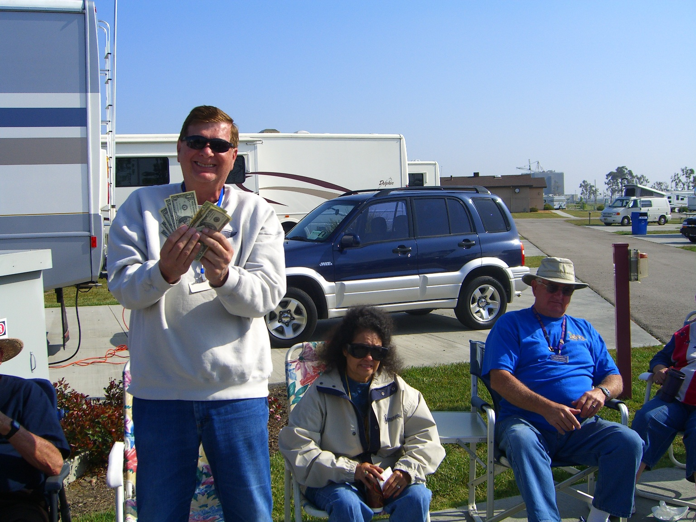

As you may imagine, the Friday night “Pot
Luck” had a whole bunch of great food and our
generous wagon masters had brought a wonderful
Chinese meal in Saturday night.

Lots of games were played and the campfires were welcomed on the chili evenings. Much was covered at the Sunday morning meeting, including; Rally ideas and the up-coming Rally meeting at our lodge May 1st, the lodge awnings, shirts, jackets & badges, Culinary volunteers at the lodge, the nest campout, the August & November campouts and tips at the lodge.

YOU ARE ALL INVITED to the Hilltoppers’ July campout. It’s a meet-n-greet, so even if you don’t have an RV, come on out and enjoy some camaraderie & games for a day. Come see who we are & what we do (July 17th 10am – 4pm) at Featherly Park (Canyon RV) Gypsum Canyon just north of the 91 Fwy, in Anaheim Hills. Bring the family & a picnic lunch and we’ll supply the fun. The park will charge $5/car + $2/person 3 years and older.

Yours in Service,

PER, Scott Stephens

