Treasure Hunt Weekend for the Hilltoppers
After our campout plans had fallen through twice, Mary Kay and I hosted a quaint little campout out at our own lodge August 20-22. Geoff and Vivian had to cancel just a week or so before the campout (due to a surprise family visit), but that still left 5 rigs full of people looking to support the lodge and have fun together. I must say I was very pleased with the way everything turned out that weekend and wished more of our members could have shared.

The ten of us were joined by four of our friends from Buena Park for dinner here at The View dining room, Friday night. Sunday morning Mary Kay and I made everyone a big breakfast with Omelets in a bag, potatoes, bagels, fruit & some of Lupe’s yummy brownies. It was the time we spent together Saturday, that is still being talked about.
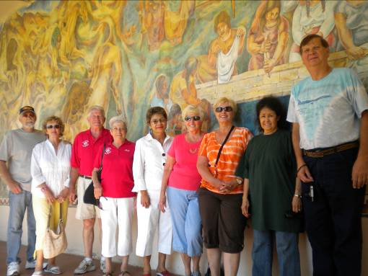
Jackie Kilpatrick & Ellie Castillo, who were intrigued enough by my illusive outline of what was to happen on Saturday, joined in on this wonderful day of hidden treasures throughout Fullerton. We all left the lodge at 10 am, heading toward our first stop, Villa del Sol (which was the old California Hotel built in 1922). After some shopping, site seeing and ghost stories there, we visited 3 murals in the area, including the one in the police department, which was the original city hall council chambers. Then off to lunch at this little hideaway called the Veronese Cafe.

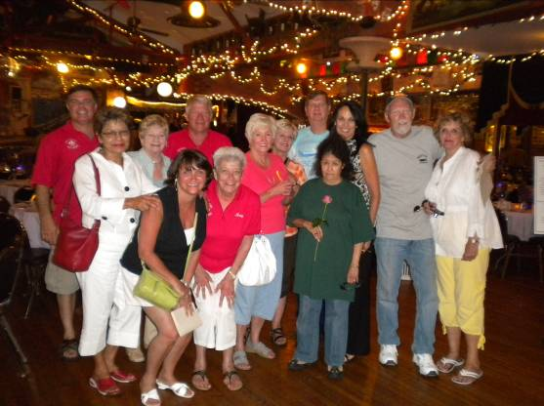
From there we were treated to a private tour of The Muck, and drove by 3 other murals around town before heading into the main post office (built in 1939) which houses the oldest mural in town. After a complimentary trip through the Fullerton Museum, with its “10,000 Years of Beer” exhibit, we stopped at Mulberry Street for a couple of cocktails and some wonderful hors d’oeuvres (also included in the campout fees).

We went up to the fabulous 360* views at Hillcrest park, saw the huge “fresco” style mural at the Plummer and then were treated to a private tour of Angelo’s & Vinci’s, by its very gracious owner, Cynthia Peck. The secrets we learned that day will stick with us the rest of our lives.

After a brief rest and a couple of cocktails at our rigs we headed back out for the evening. The outdoor dinner and entertainment for the evening were a beer and a dog at the Flyers baseball game. Some fussed a little before we left, but after the game everyone stated they had a great time.
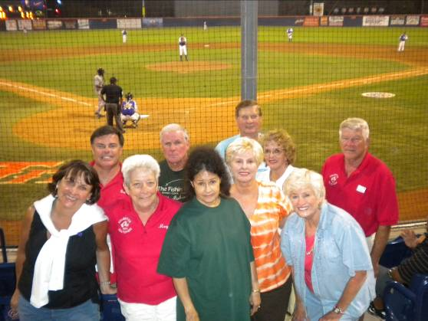

Thanks to all who enjoyed it with us and for all your kind accolades. We enjoyed doing it.
We hope to see the rest of you at these upcoming campout/events; October 15–17 @ Oceanside Elks Lodge, November 5-7 @ Emerald Desert and December 5th for Christmas Tree Lane @ Fullerton Elks Lodge.

Yours in Service, Scott Stephens

