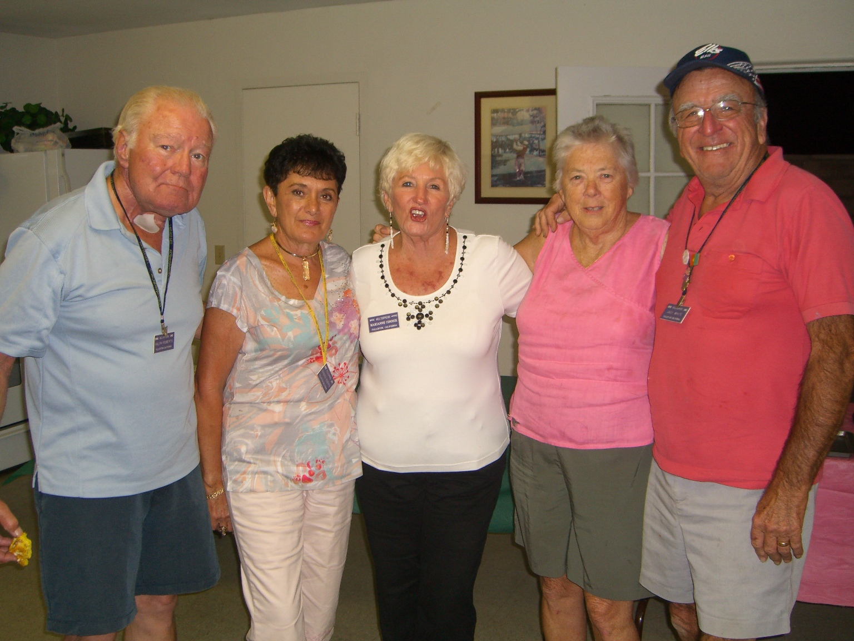
Palm Springs in November
The first weekend in November turned out to be a much better fit for everyone. Our Wagon Masters (Ralph & Barbara Roberts, Marianne Conner, Mary & Jack White) realized that Thanksgiving, family and travel made it very difficult for our members later in the month. So after asking around they switched weekends and it turned out wonderfully.
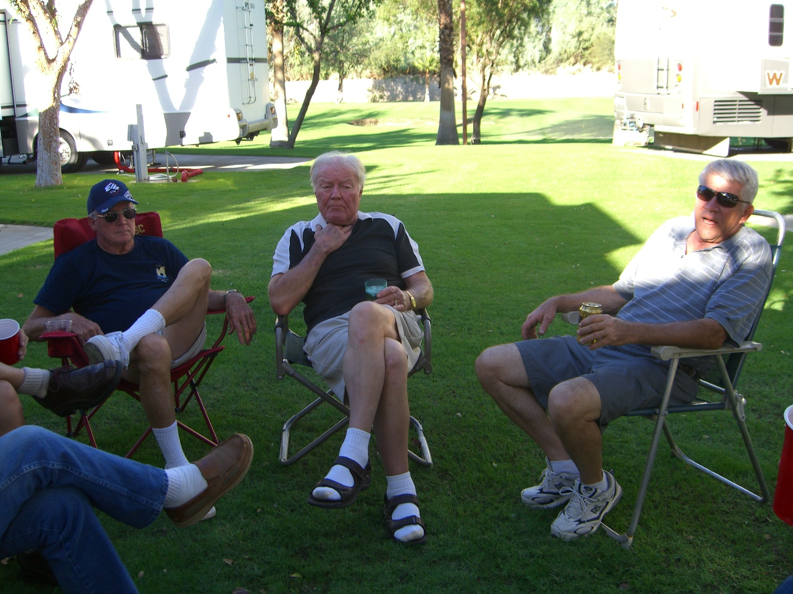

The weather man was a little off, but in our favor this time. It was a fabulous 78-83 degrees all weekend. This, coupled with the lush grounds at the Emerald Desert Campground, made for VERY pleasant visiting throughout the days. Some chose the pool, some played indoor games, but most enjoyed the camaraderie of their fellow Hilltoppers in this lovely setting.

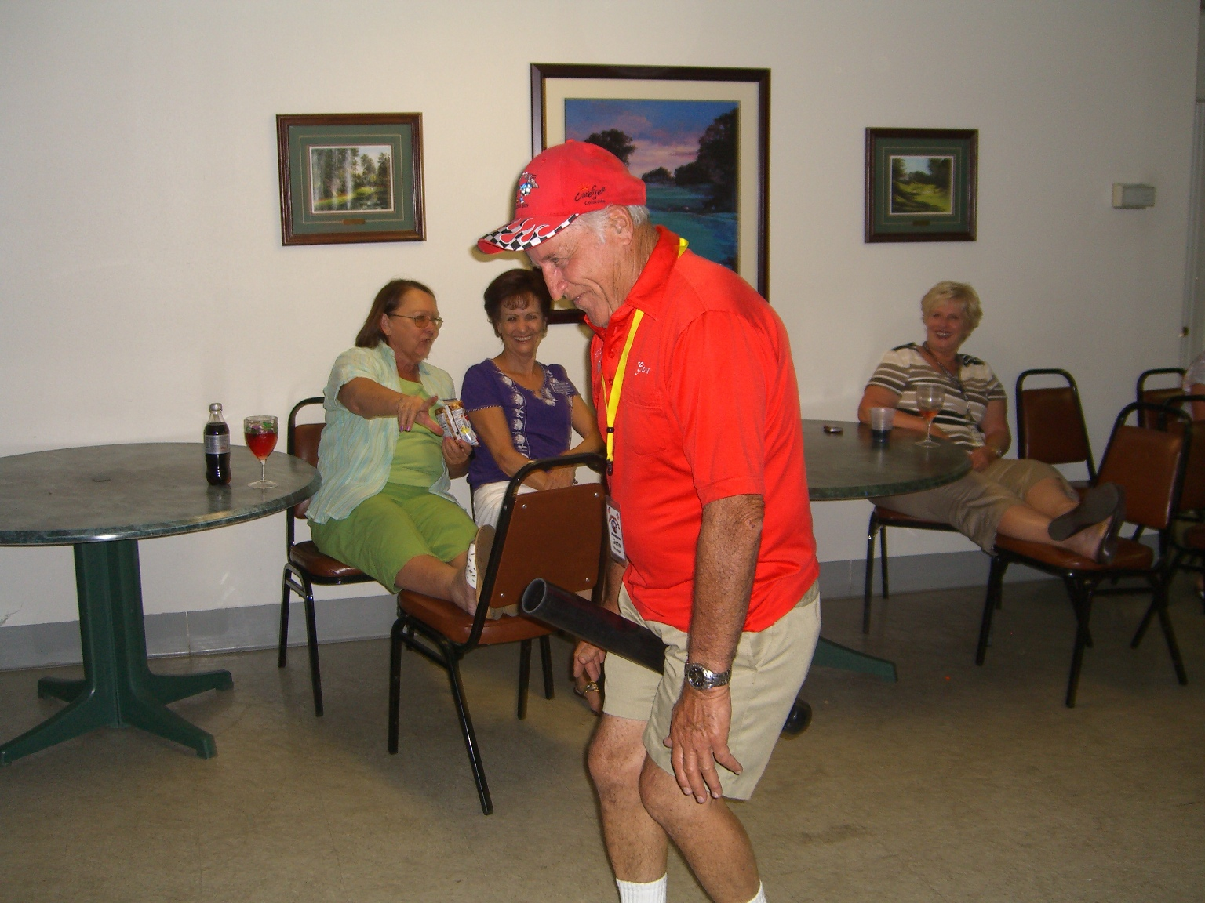
The meals were again a pleasant surprise; Deli sandwiches Friday night with potluck salads, and grill-your-own, meat on Saturday, with more potluck salads. There were even some ambrosia salads with the continental breakfast on Sunday.

The Saturday night games we are not going to forget for quite some time. It’s impossible for me to explain exactly what transpired that evening, but it suffices to say that everyone was in stitches. For those who weren’t in attendance, you’ll probably here the stories (at least part of them) for a long time to come.

Hope to see most of you at the campouts that are planned for 2011.

January 20 - ? - Quartzsite (Louie & Button Burke) July 15, 16, 17 –
February 18, 19, 20 - Tucalota Springs (Stephens/Gleed) August 19, 20, 21 –
March 18, 19, 20 - OC Fairgrounds (Ling/?) September 16, 17, 18 – Seal Beach (Moore/?)
April 15, 16, 17 - Rubideau (Rose/Lowe) October??? – Hemet Rally (¿/?)
May 20, 21, 22 – Eastshore RV San Dimas (Flaherty/Hightner) November 18, 19, 20 – Emerald Desert or
June 3, 4, 5, 6 – Santa Maria Rodeo (Shumski/?) Havasu (Conners/?)
December 4th - Christmas Tree Lane

Mary Kay and I wish to thank you all for your support and we know Dick & Mary Moore will do a fabulous job as chairman.

Yours in Service,

PER, Scott Stephens

