Supporting the Oceanside Elks
Yes, again we had a nice campout down at a fellow Fraternal Organization. It doesn’t happen very often, but it is quite rewarding when we can visit and share with another Elks Lodge. Even on a cool and misty weekend like October 15-17 we all enjoyed their hospitality.

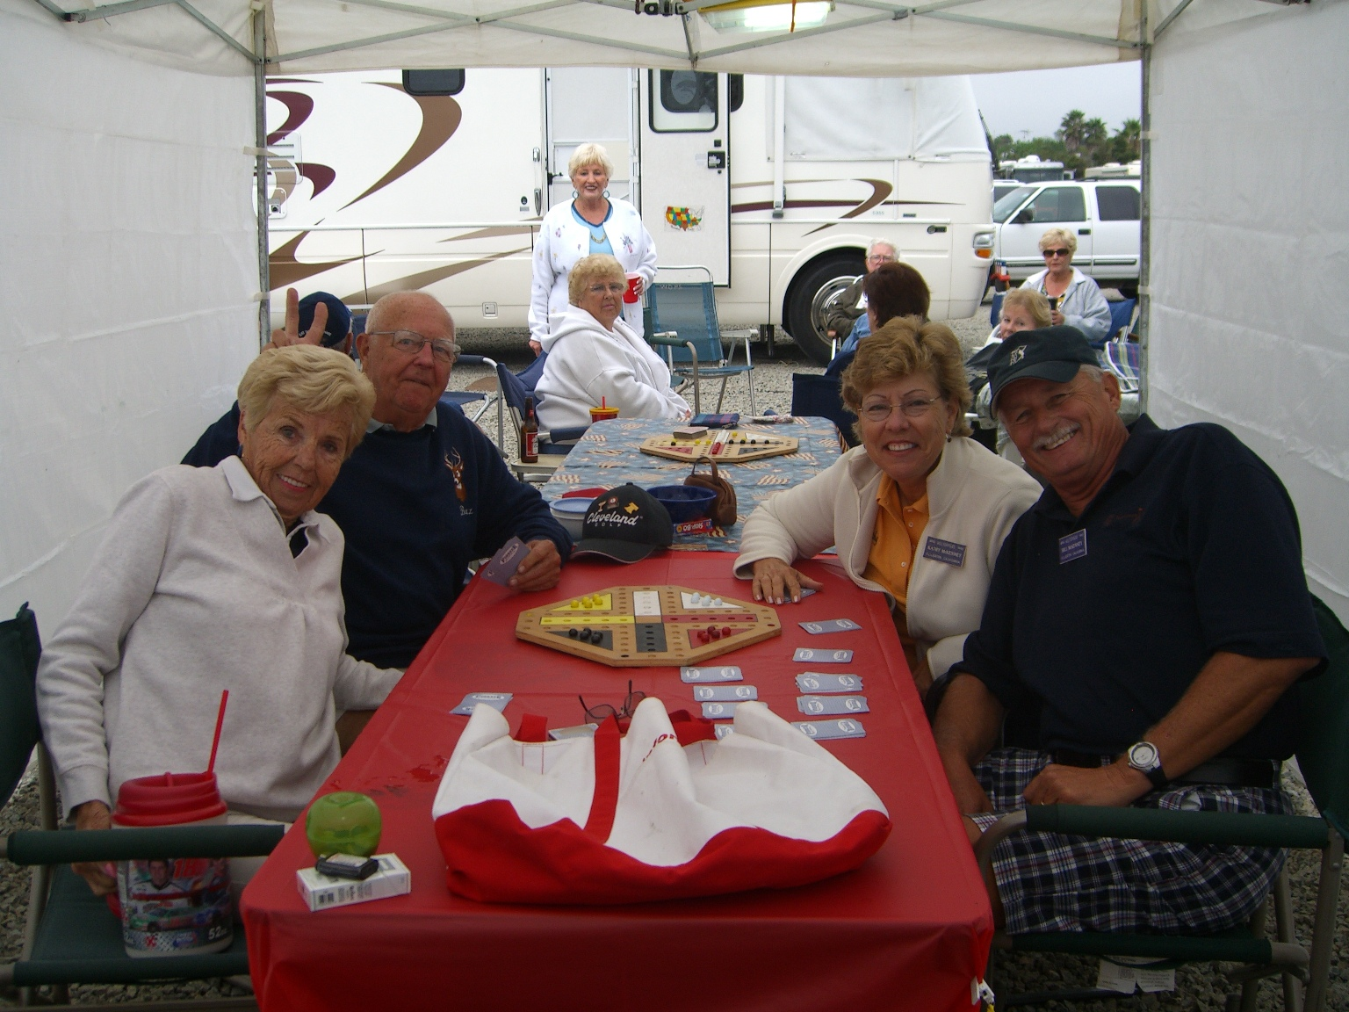
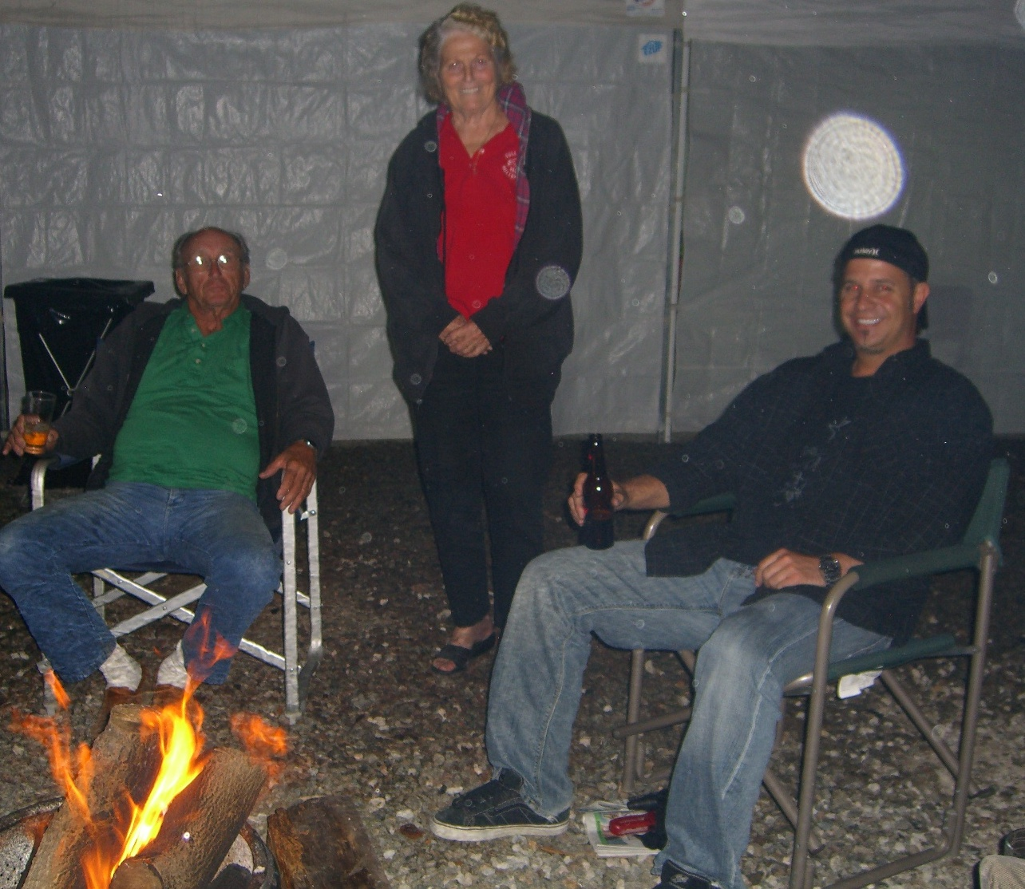
Our Wagon Masters (Buxbaums and McKenneys) kept us dry, fat and happy all weekend. The 20 rigs full of people and pets trickled in Thursday and Friday, to fill the rocky little campground at the far end of the lodge parking lot.

Our dining/gaming area was covered and toasty all weekend. We had a nice firepit & plenty of internal warmth was consumed.

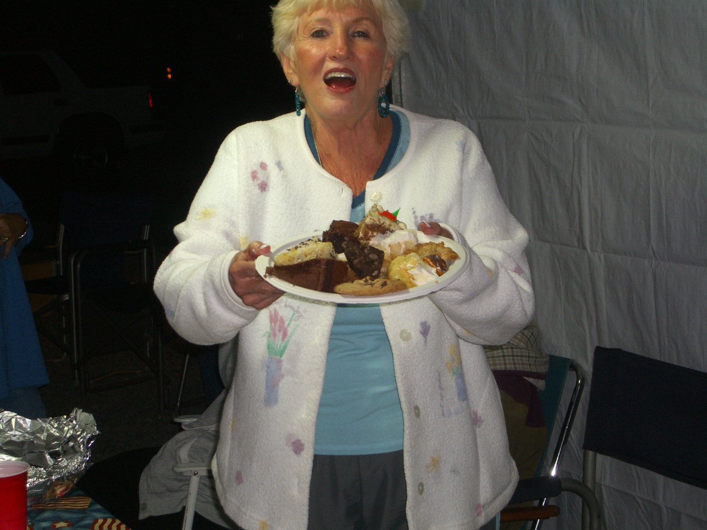
Many golfers went out to the links Friday morning for a wonderfully cool round. Friday night some ate in the lodge and some ate in their rigs. However the treat was a potluck dessert night, that topped’em as far back as I can remember. We ate those desserts all weekend long, for breakfast, lunch & dinner.

Saturday morning we were surprised by a wonderful breakfast done by Ellie, Jim & Marci. Breakfast Burritos with potatoes, beans, Chorizo, eggs and lots of sides. mmm.

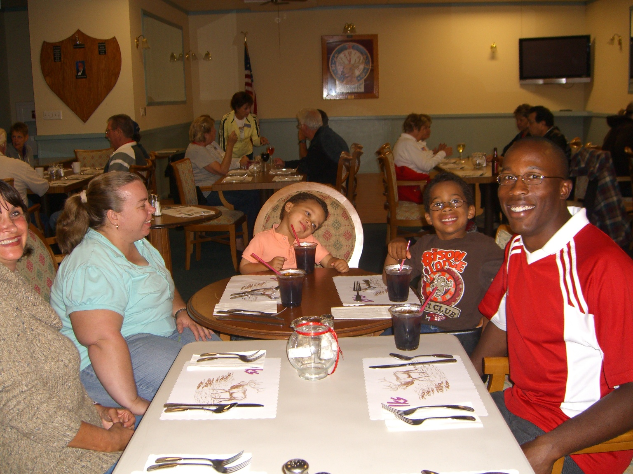
Saturday night we hosted one of our favorite Marines and his family for dinner at the lodge. Some of you may remember Cory from the Rally 3 years ago. Mary Kay and I along with our friends from the HB lodge had bought his dinner and some raffle tickets. When he had to leave on the bus with the rest of the Marine band, he left us his tickets & cell. # and much to everyone’s amazement he won.
So when Mary Kay found out he was now at Pendleton she asked him and his family to join us and share some stories. The boys were quite a handful, but it was very heart-warming to see many Elks thank Cory for his service to our country.

These are the Campouts we have planned for 2011 (so far);
January 20 - ? - Quartzsite (Louie & ButtonBurke) July 15, 16, 17 –
February 18, 19, 20 - Tucalota Springs (Stephens/Gleed) August 19, 20, 21 –
March 18, 19, 20 - OC Fairgrounds (Ling/?) September 16, 17, 18 – Seal Beach (Moore/?)
April 15, 16, 17 - Rubideau (Rose/Lowe) October??? – Hemet Rally (¿/?)
May 20, 21, 22 – Eastshore RV San Dimas (Flaherty/Hightner) November 18, 19, 20 –
June ??? – Santa Maria Rodeo (Shumski/?) December 4th - Christmas Tree Lane

All Elks are welcome to attend (many of the campgrounds have rentals available). If you wish to get on our mailing list, to get an invite and all the information every month, join the club for only $25/year.
Yours in Service, Scott Stephens

