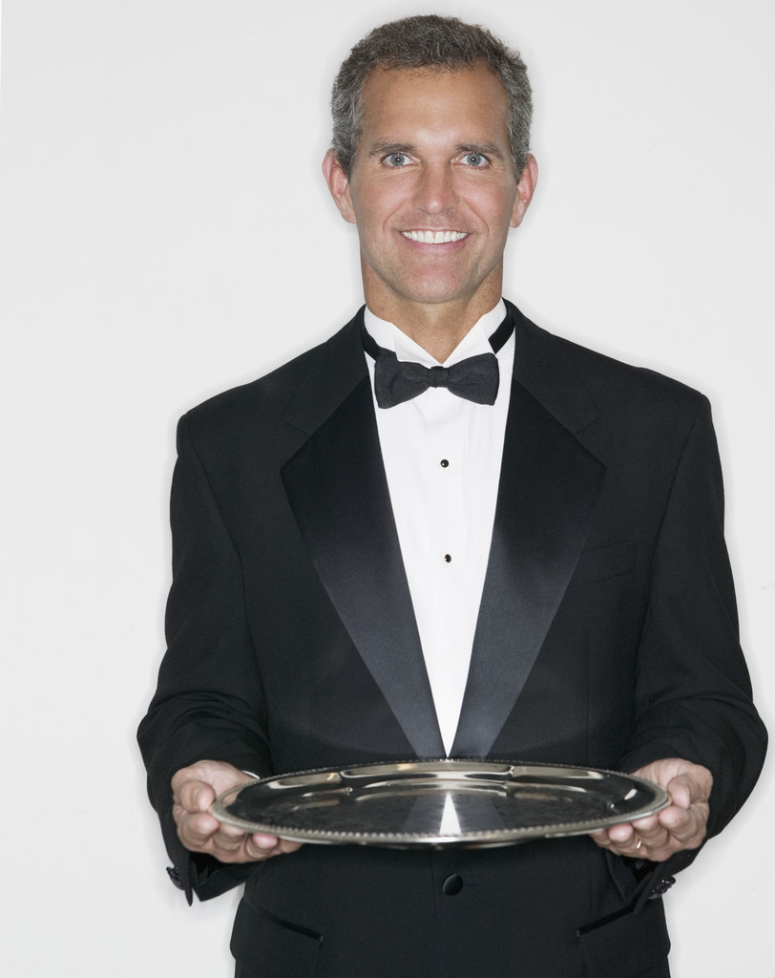
STUD AUCTION
District Fundraiser for Art Echternacht’s CHEA Presidential Year

February 25, 2012 at the Fullerton Elks Lodge
5:30 cocktails, 7pm dinner & 8:30 auction

Succulent Slow Roasted Barron of Beef, carved to your liking
or Roasted ½ Chicken, with a plethora of yummy sides.
Our full list of wines will be available to compliment your wonderful meal.

The District wide STUD list
with their accompanying treats

Bob Genelle, Orange, PDDGER – Your personal chef for an evening, will prepare a fabulous 4 course Italian Meal with wine, for up to 6 people at your home…Fugetaboutit

Jim Vecchio, La Habra, PDDGER – a Harley Trike ride, through beautiful Trabuco Canyon, with pick up & delivery @ your door (includes lunch @ Cooks Corner) & possibly a scenic ride down the coast.

Mike Mathers, Fullerton, PSVP – all inclusive weekend @ his Mountain Cabin, great trout fishing, all meals, wines & other libations included.

David Leonard, Newport, PER - with a Gondola ride for up to 14 people in the luxurious Newport Harbor.

Tom Lemm, Huntington Beach, DDGER - 4 La Mirada, theater tickets and dinner for 4. The Lemms & Echternachts will join you (schedules permitting) for a night of Royalty for you and your guests.

Art Echternacht, Santa Ana, PDDGER and the man of the hour – has a 2bd. 2ba. Laughlin Condo donated by Kathleen Murray (1-2 couples, Mon-Thur. or Fri-Sun).

Scott Stephens, Fullerton, PER – Will Host 3 couples for a 7 course meal at his hilltop, pool home. Complete with a full bar, paired wines and Cappuccino.

Brian Hogan, Fullerton Trustee – In home Tech Support. He’ll help you clean up, defrag, restore, back up and/or protect your home or office computer (up to 4 hours of labor included).

Dan Casey, Fullerton PER – 2 hours of Handyman Services. Since he used to work for "Handyman Connection", he offers quality labor on any project you like (buyer pays for the materials).

Jack Ehlers, Fullerton Chairman of the Board – A licensed contractor offering 1 day’s labor on ANY home improvement project (buyer pays for material).

You Won’t want to miss out on this Fabulous night of Flesh-For-Sale Fun.

RSVP with your check for $12 per person, payable to the Fullerton Elks Lodge (write “STUD” on the notes line) and mail it to 1400 Elks View Lane, Fullerton, CA 92835. RSVP deadline is February 12, 2012. After that the price will be $17/person if any of the limited seating is still available. Don’t delay! Send your check Today! Hosted by the Fullerton Elks’ PERs. Call Scott Stephens with questions at (714) 801-6230.

