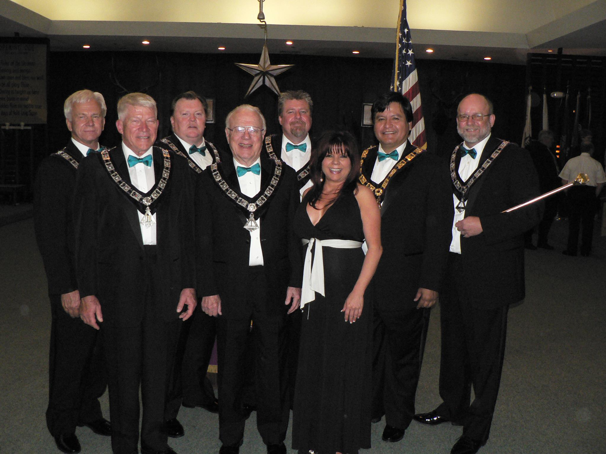

The Fullerton Elks Ritual Team thanks you for your support! Congratulations to all the competing teams.

